**CareWell**  
**A Comprehensive Hospital Management System**

**Prepared by:** Adarsh Dhakar, Avik Sarkar, Debargha Nath, Soham Chakraborty

**🔗 Project Links**

* [🌐 CareWell Live](https://carewell-future.netlify.app/)
* [📬 API Documentation (Postman)](https://documenter.getpostman.com/view/40480117/2sB2iwEETs)
* [📦 Submission Repository (GitHub)](https://github.com/DebarghaNath/DBMS_PROJECT_HOSPITAL_MANAGMENT)
* [🧩 ER Diagram (PDF)](https://github.com/DebarghaNath/DBMS_PROJECT_HOSPITAL_MANAGMENT/blob/main/Idea_er_diagram.pdf)
* [📄 Theoretical Documentation (PRD)](https://docs.google.com/document/d/1zjn1w_RHEjrcuj0rtWkFTKLyTxPXaBFwDBW5odpLO-Y/edit?usp=sharing)
* [📌 Workflow Management (Asana)](https://app.asana.com/0/1209820690287935/1209823225591449)

**Table of Contents**

1. **Introduction**
2. **System Overview**
   1. Objectives & Scope
   2. Key Assumptions
3. **Architecture & Data Model**
   1. Technology Stack
   2. ER Diagram
4. **Functional Features**
   1. User Roles & Permissions
   2. Patient Management
   3. Appointment & Scheduling
   4. Diagnostics & Reporting
5. **REST API Reference**
   1. Authentication & User Management
   2. Appointment Endpoints
   3. Room Management
   4. Doctor APIs
   5. Test & Result APIs
   6. Miscellaneous Services
6. **Appendix**

Screenshots

**1. Executive Summary**

CareWell is a modular, role‑based hospital management platform designed to handle operations across **Front Desk, Data Entry, Medical, and Administrative** teams. It **centralizes patient data**, automates **scheduling**, integrates **diagnostics**, and provides analytics dashboards to support decision‑making and improve patient care.

**2. System Overview**

**2.1 Objectives & Scope**

* Provide a unified interface for patient registration, appointment booking, admissions, diagnostics, and discharge.
* Ensure data integrity, security, and role‑based access controls.
* Offer real‑time analytics and reporting to administrators and clinicians.

**2.2 Key Assumptions**

* **User Activity**: Tracks lastLogin; inactive after 30 days. Auto‑login if dashboard revisited within session.
* **Appointment Types**: Emergency (e.g., Cardiac Arrest), Medium (e.g., Skin Conditions), Normal (e.g., Fever).
* **Ward Types**: General, ICU, Emergency, Pediatrics, Maternity, Surgical.
* **Notes & History**: Stored as semicolon‑separated entries.
* **Lab Scheduling**: Fixed-duration slots (5 labs × 30 min).
* **Doctor Scheduling**: One-hour appointment slots.

**3. Architecture & Data Model**

**3.1 Technology Stack**

| **Layer** | **Technology** |
| --- | --- |
| Backend | Node.js, Express.js |
| Database | Supabase (PostgreSQL) |
| Frontend | React.js, Tailwind CSS |
| Auth & Security | JWT, bcrypt |
| Storage & Files | Multer, Cloudinary |
| Messaging | Twilio (SMS), Nodemailer (Email) |

**3.2 ER Diagram**

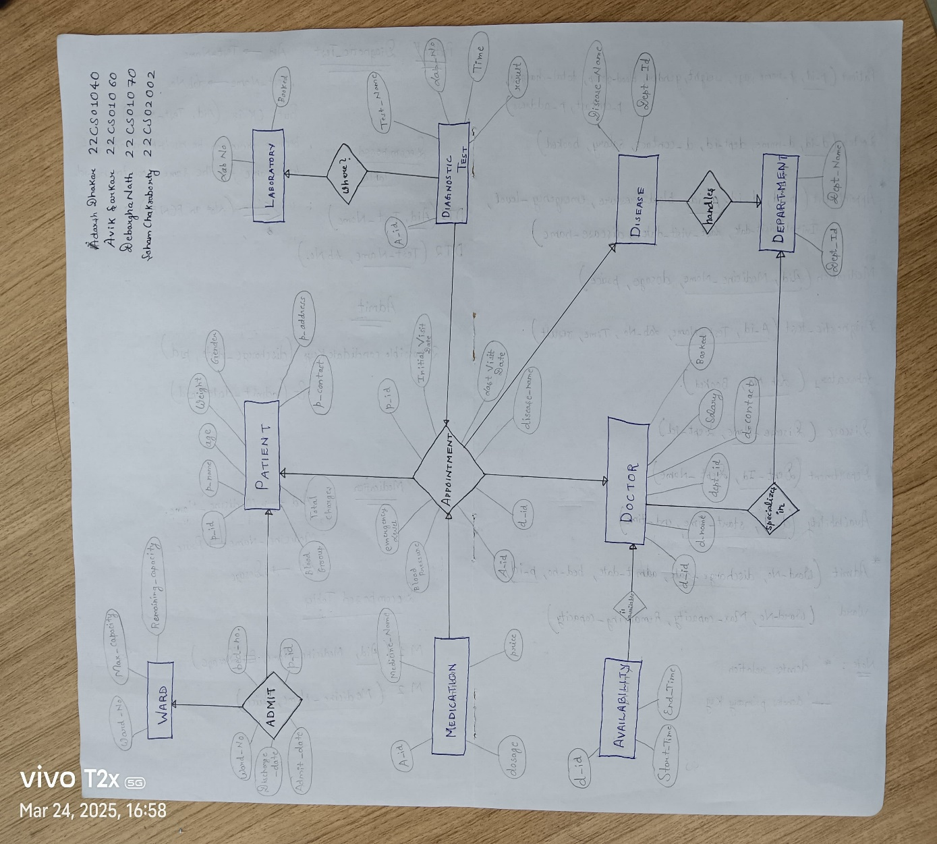

**4. Functional Features**

**4.1 User Roles & Permissions**

* **Admin**: Full system analytics, user management
* **Front‑Desk Operator**: Patient registration, appointment booking, admissions/discharges
* **Data‑Entry Operator**: Test results entry, medication prescription logging
* **Doctor**: View patient history, prescribe treatment, consult diagnostics

**4.2 Patient Management**

* Register new patients with Aadhaar verification
* Update demographics, contact, and insurance details
* Discharge workflows with billing integration

**4.3 Appointment & Scheduling**

* Book, view, modify, and cancel appointments
* Auto‑assign doctors and labs based on availability
* Support for emergency, medium, and routine visits

**4.4 Diagnostics & Reporting**

* Schedule and record tests: Blood, X‑Ray, MRI, CT, ECG, Ultrasound, Urine
* Store parameters (e.g., Hemoglobin, WBC count) with units
* Radiologist notes, image uploads, and sequence metadata

**4.5 Billing & Notifications**

* Generate invoices upon discharge or service completion
* Send SMS/email reminders for upcoming appointments or test results

**5. REST API Reference**

**5.1 Authentication & User Management**

| **Method** | **Endpoint** | **Description** |
| --- | --- | --- |
| **POST** | **/api/authorization/login** | **User login** |
| **GET** | **/api/authorization/getdetails** | **Fetch current user details** |
| **GET** | **/api/authorization/checkaadhaar** | **Verify Aadhaar availability** |
| **POST** | **/api/authorization/signup** | **New user signup** |
| **PUT** | **/api/authorization/addusers** | **Admin adds new user** |
| **GET** | **/api/authorization/showusers** | **List all users** |
| **DELETE** | **/api/authorization/deleteusers** | **Remove a user** |
| **PUT** | **/api/authorization/submit-password** | **Password reset** |
| **PUT** | **/api/authorization/logout** | **Logout** |

**5.2 Appointment Endpoints**

| **Method** | **Endpoint** | **Description** |
| --- | --- | --- |
| **POST** | **/api/appointments/book** | **Book an appointment** |
| **GET** | **/api/appointments/getappointments** | **Fetch all appointments** |
| **GET** | **/api/appointments/:id** | **Get appointment by ID** |
| **DELETE** | **/api/appointments/:id/cancel** | **Cancel an appointment** |
| **GET** | **/api/appointments/getdoctors** | **Get list of available doctors** |

**5.3 Room Management**

| **Method** | **Endpoint** | **Description** |
| --- | --- | --- |
| **POST** | **/api/rooms/admitpatients** | **Admit a patient to a room** |
| **PUT** | **/api/rooms/dischargepatient** | **Discharge a patient** |
| **GET** | **/api/rooms/allrooms** | **Get list of all rooms** |
| **GET** | **/api/rooms/admissions** | **Get list of current admissions** |

**5.4 Doctor APIs**

| **Method** | **Endpoint** | | **Description** |
| --- | --- | --- | --- |
| **GET** | **/api/doctor/{doctorId}/appointments** | **Get doctor's appointments** | | |
| **GET** | **/api/doctor/{doctorId}/patient/{patientId}** | **Get specific patient details for doctor** | | |
| **GET** | **/api/doctor/{doctorId}/patient** | **Get all patients under a doctor** | | |

**5.5 Test & Result APIs**

| **Method** | **Endpoint** | **Description** |
| --- | --- | --- |
| **POST** | **/api/test/add** | **Add new test entry** |
| **POST** | **/api/test/schedule** | **Schedule a lab test** |
| **GET** | **/api/test/{patientId}/{testId}** | **Get test result by patient and test ID** |
| **POST** | **/api/doctor/{doctorId}/patient/{patientId}**  **/prescription** | **Add prescription for a patient by a doctor** |

**5.6 Miscellaneous Services**

| **Method** | **Endpoint** | **Description** |
| --- | --- | --- |
| **POST** | **/upload** | **File uploads** |
| **POST** | **/mailer** | **Email notifications** |
| **GET** | **/test** | **Health check** |
| **GET** | **/api/patient/showpatients** | **List all patients** |

**6. Collaborators**

* Adarsh Dhakar (22CS01040)
* Avik Sarkar (22CS01060)
* Debargha Nath (22CS01070)
* Soham Chakraborty (22CS02002)

**7. Appendix**

* 1. **Screenshots**

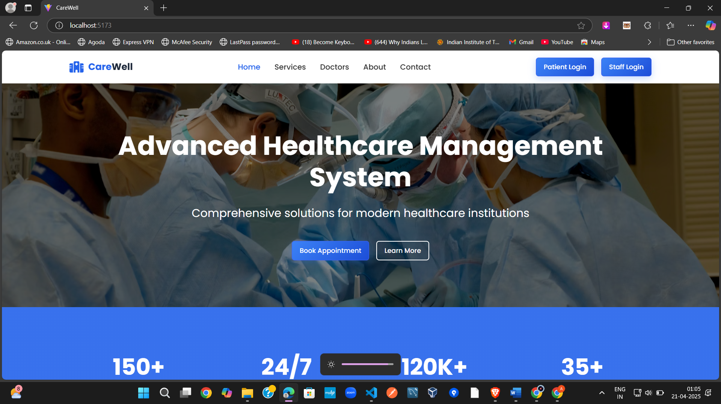

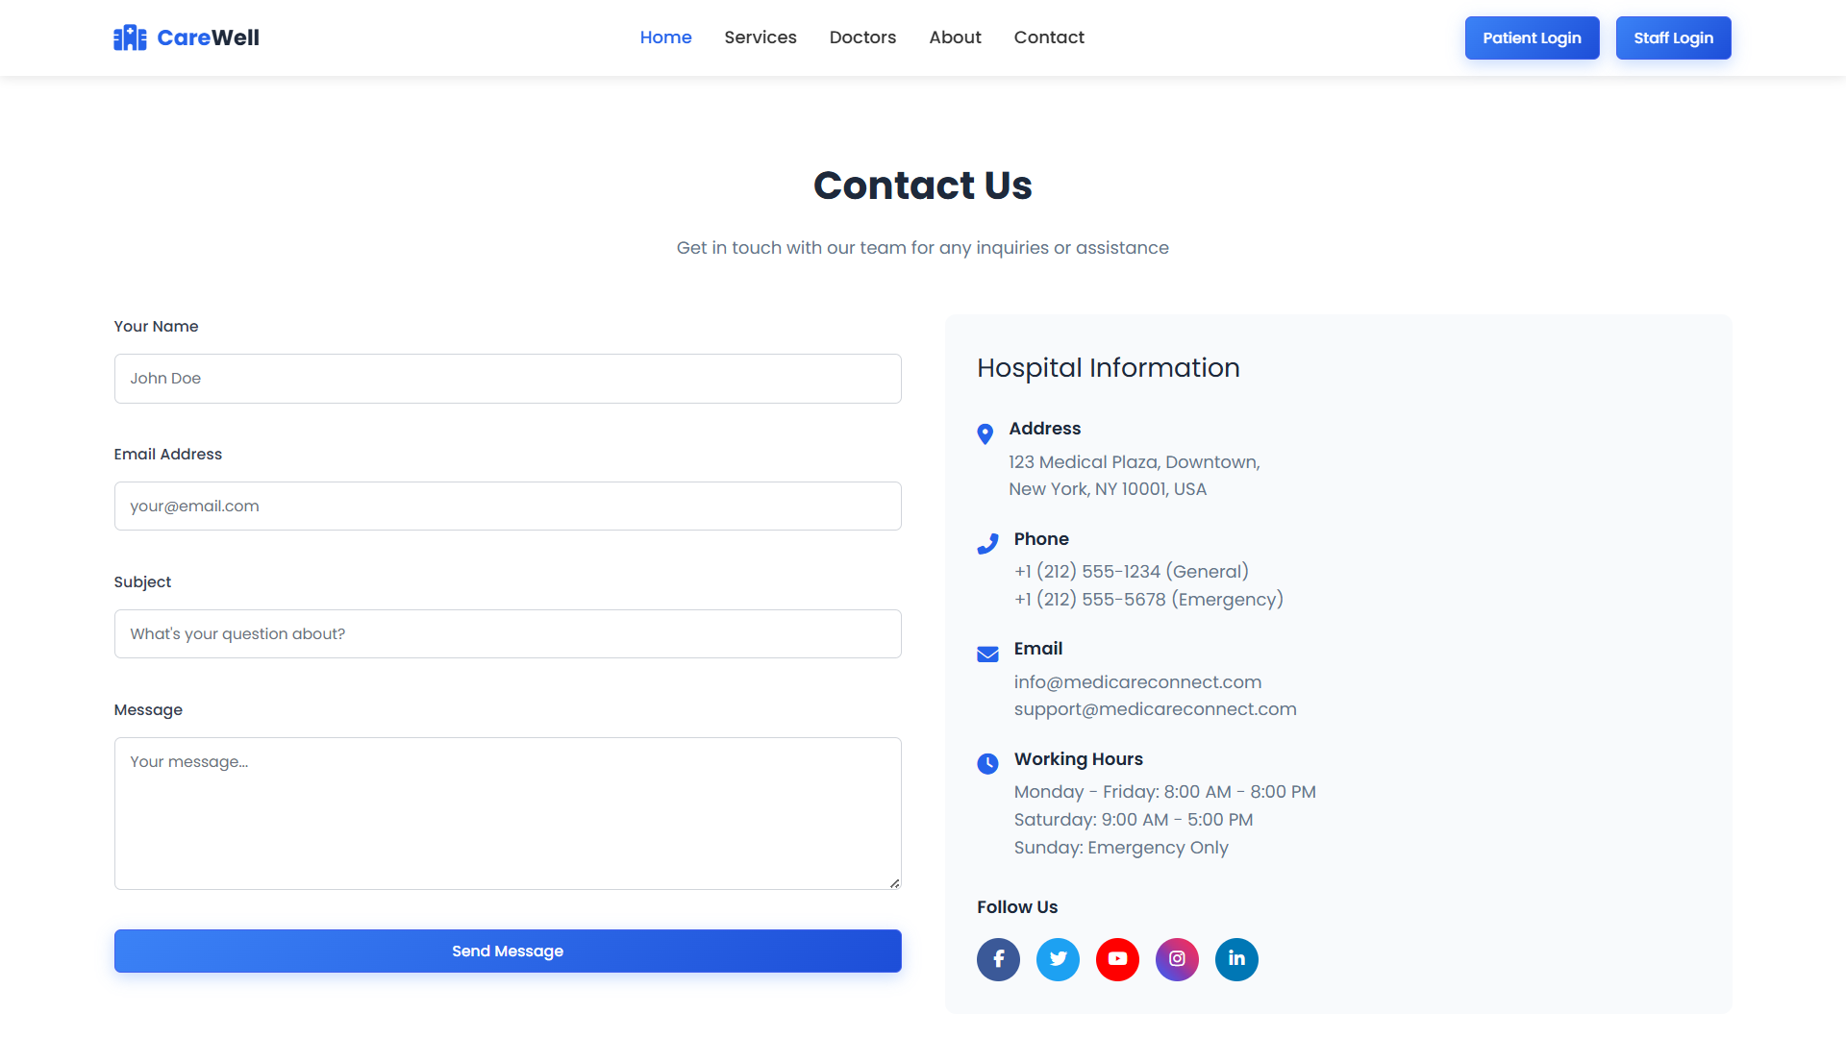

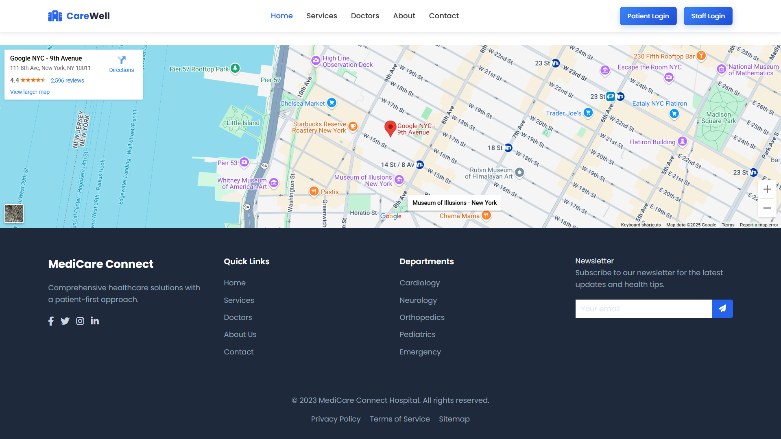

Login Page:

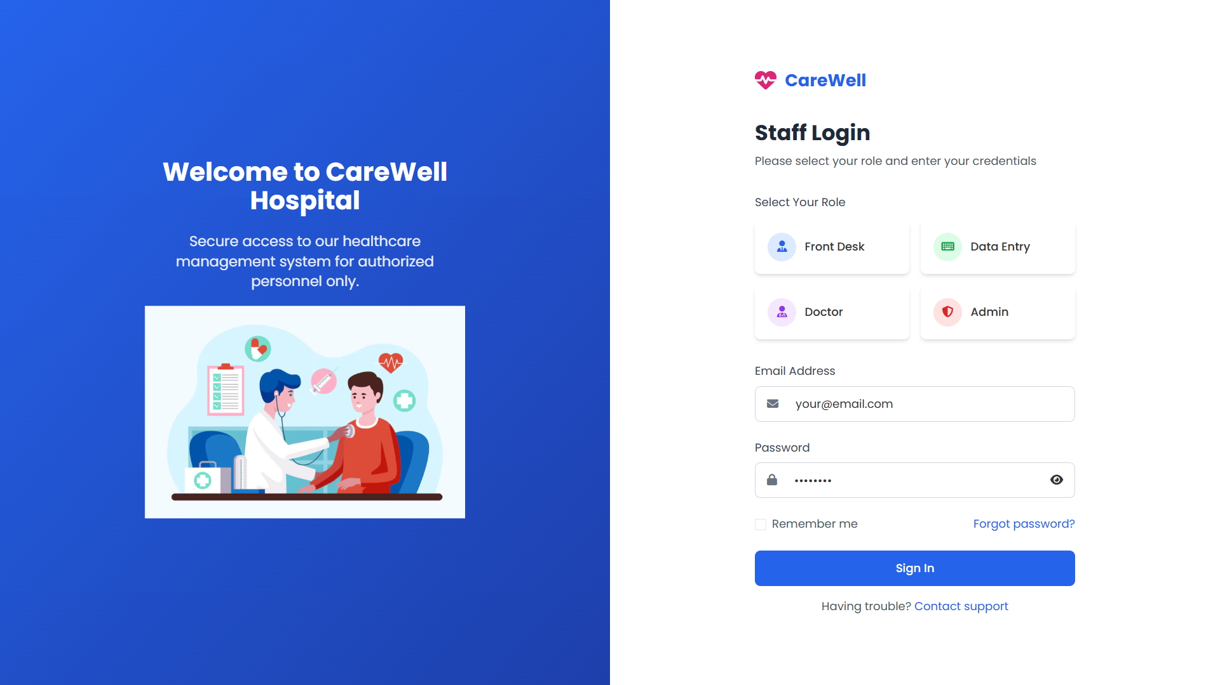

Admin:

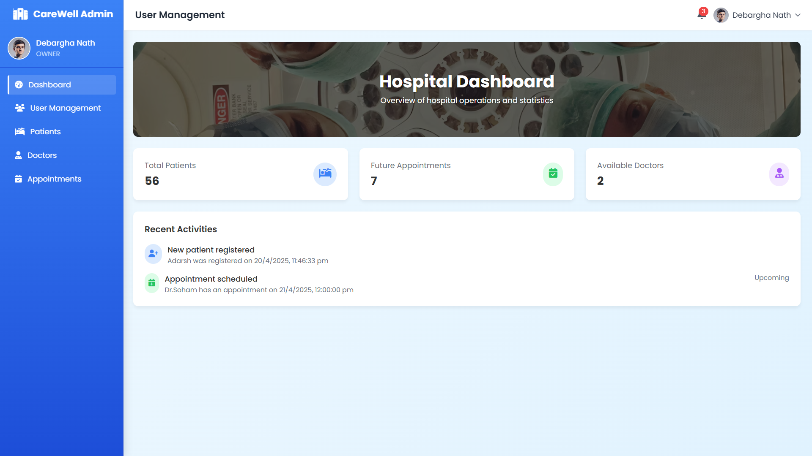

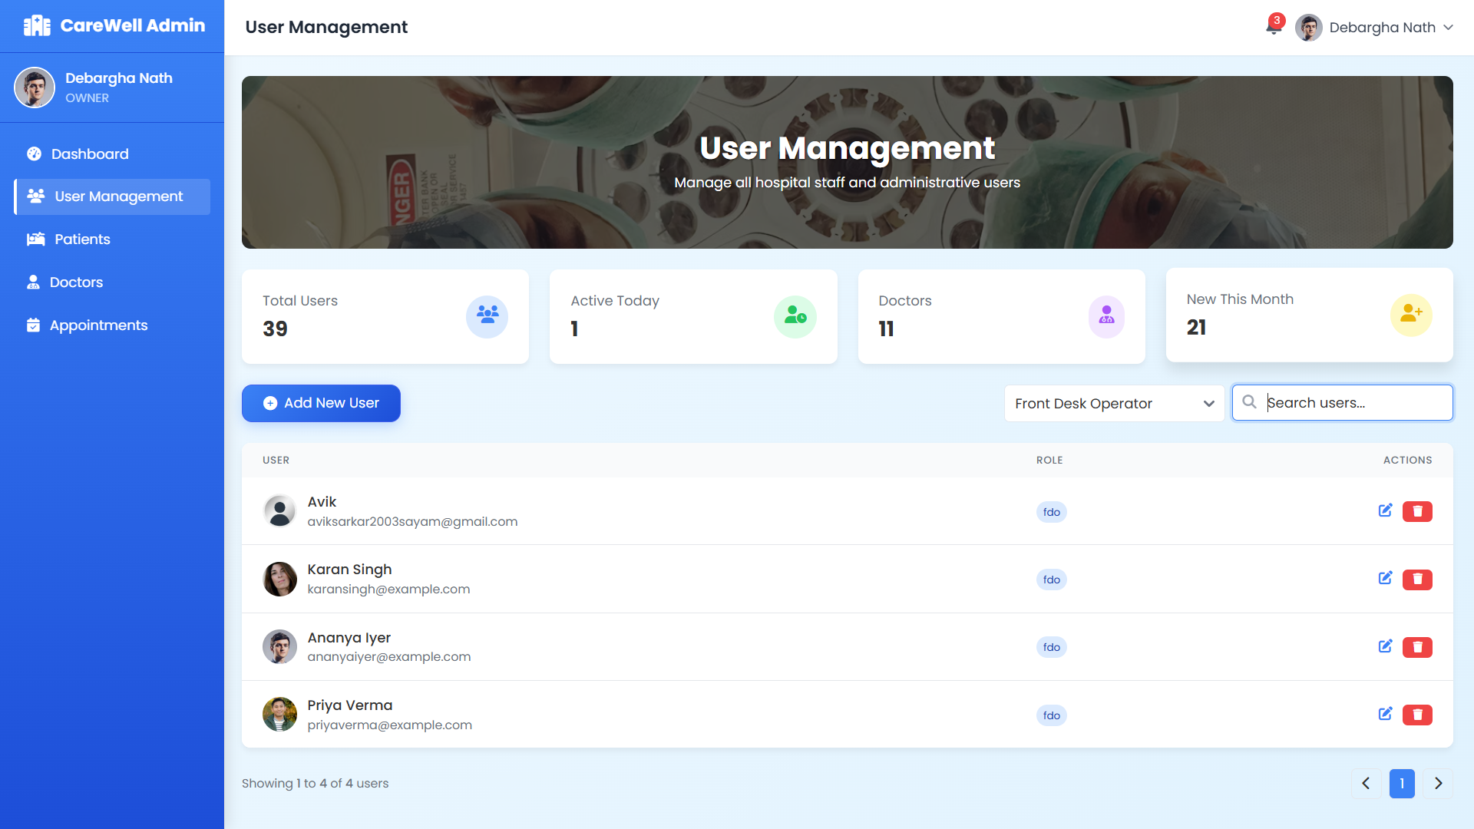

Add User

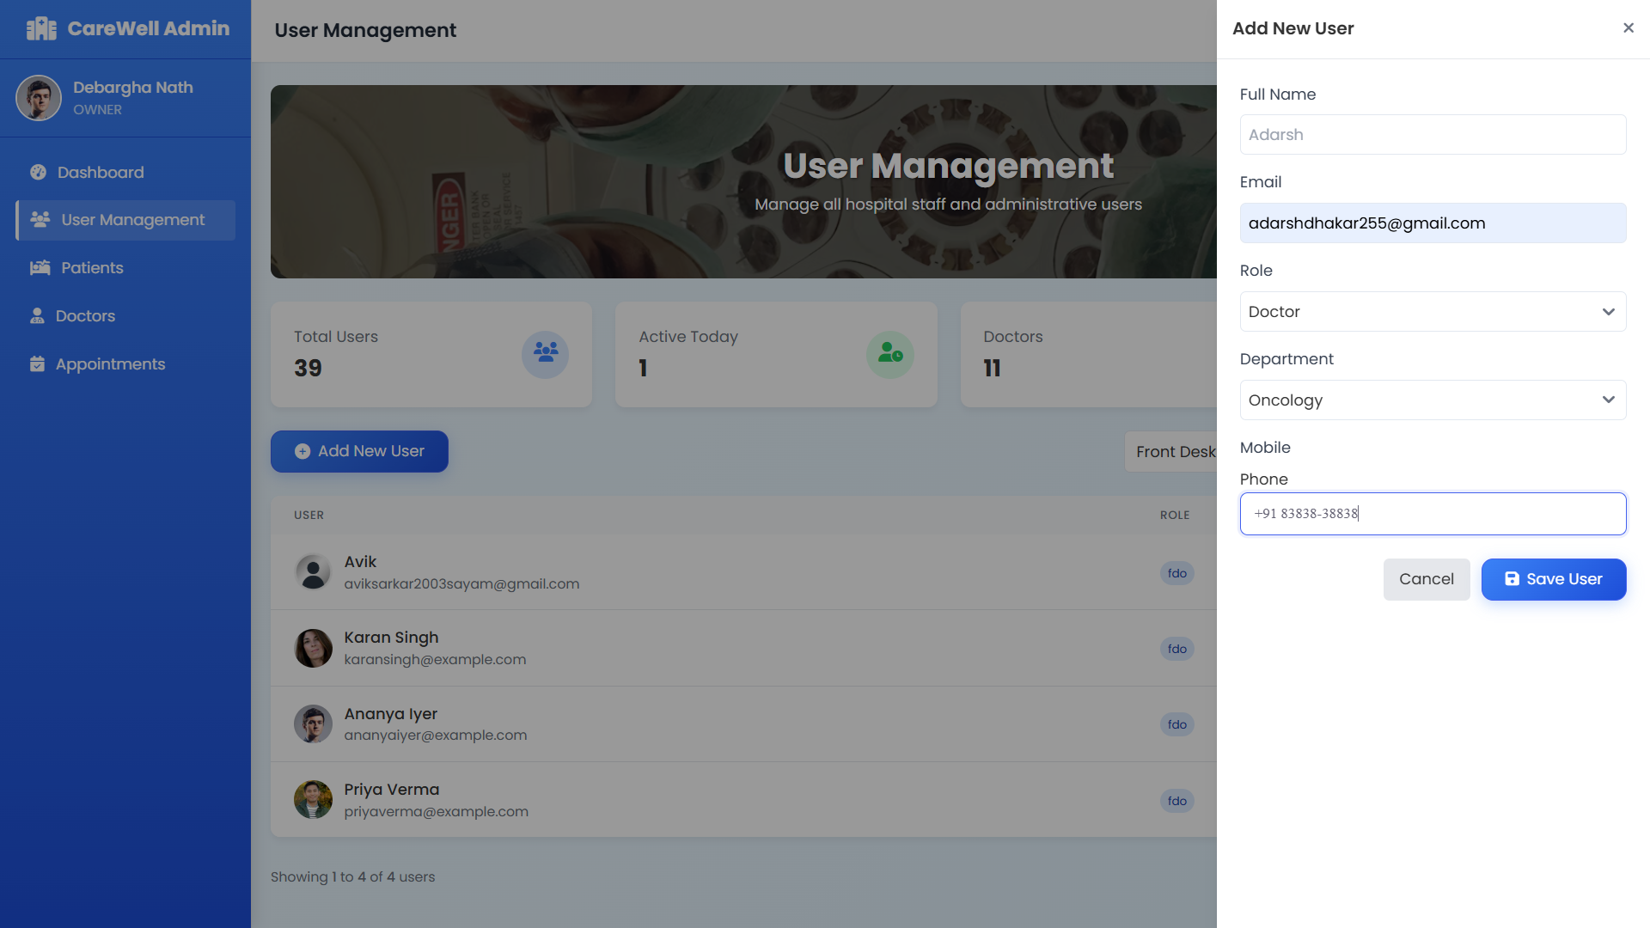

Delete User

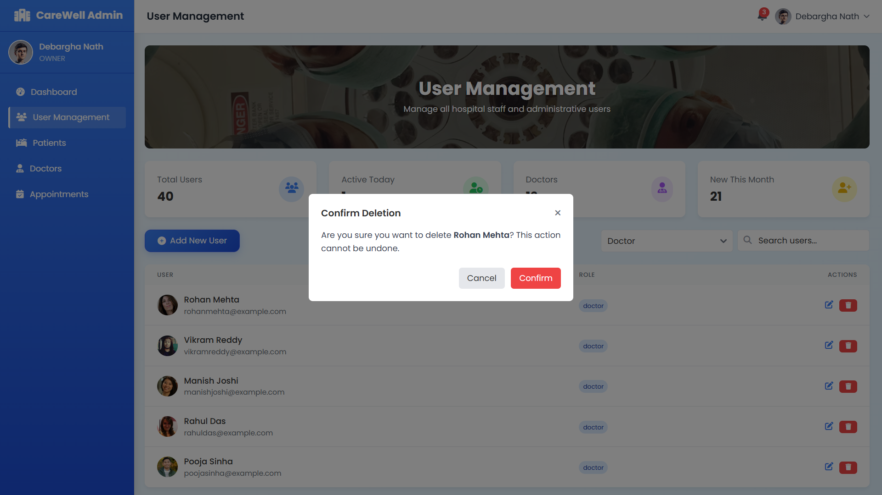

Front-Desk Operator:

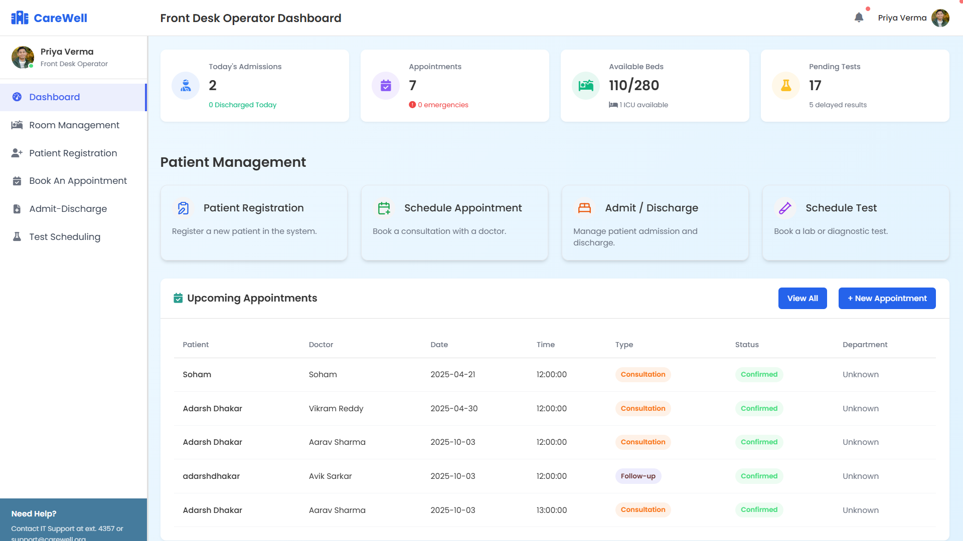

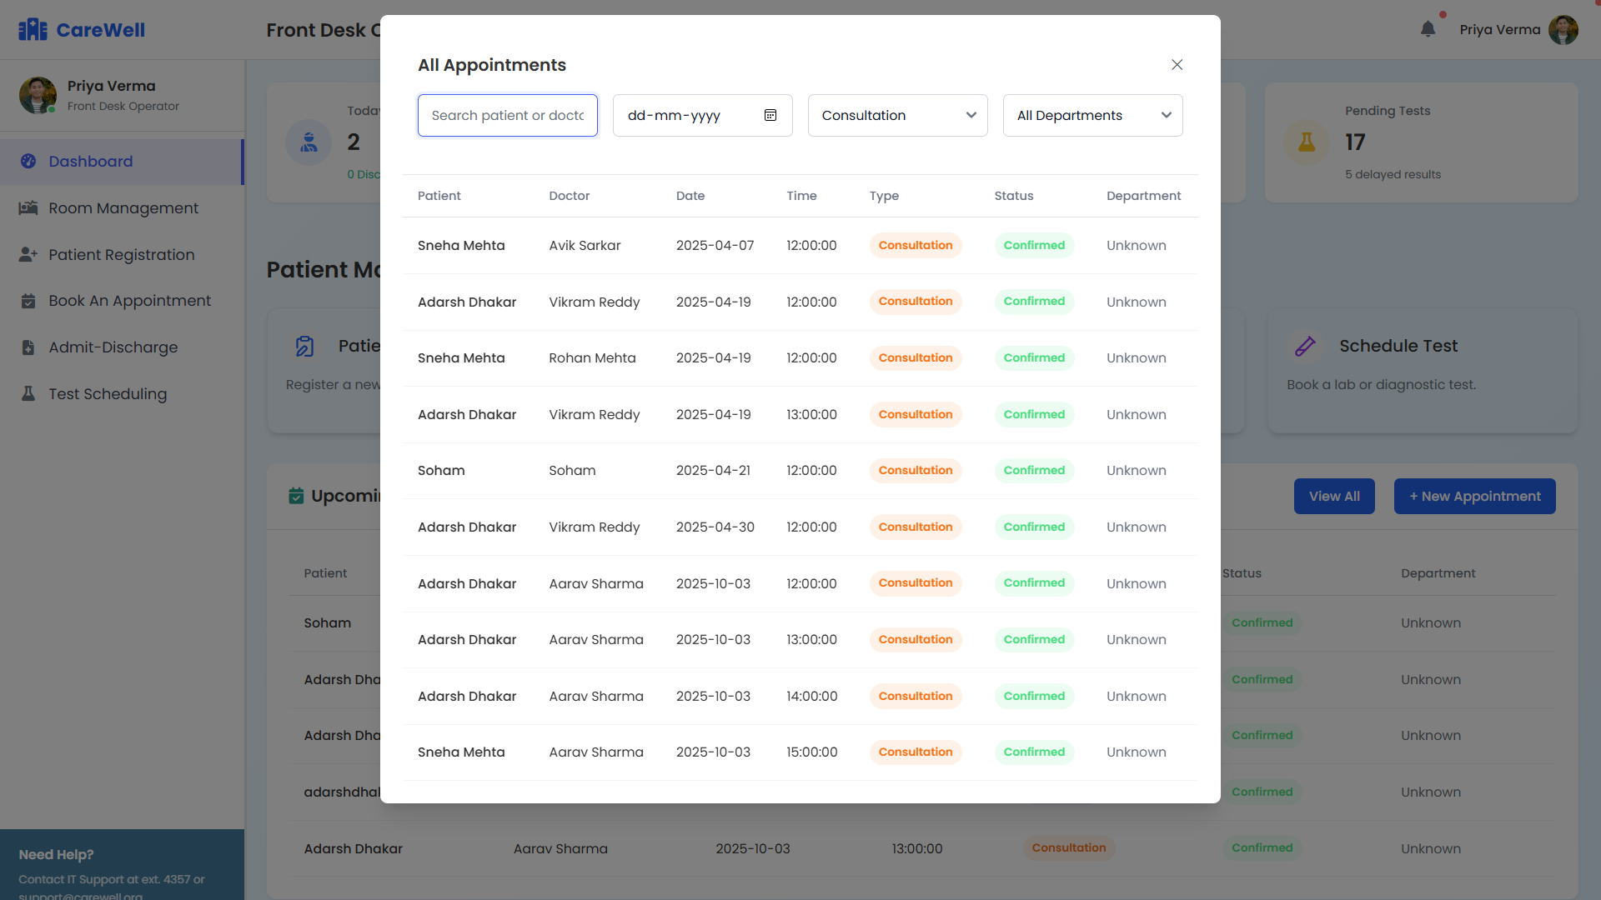

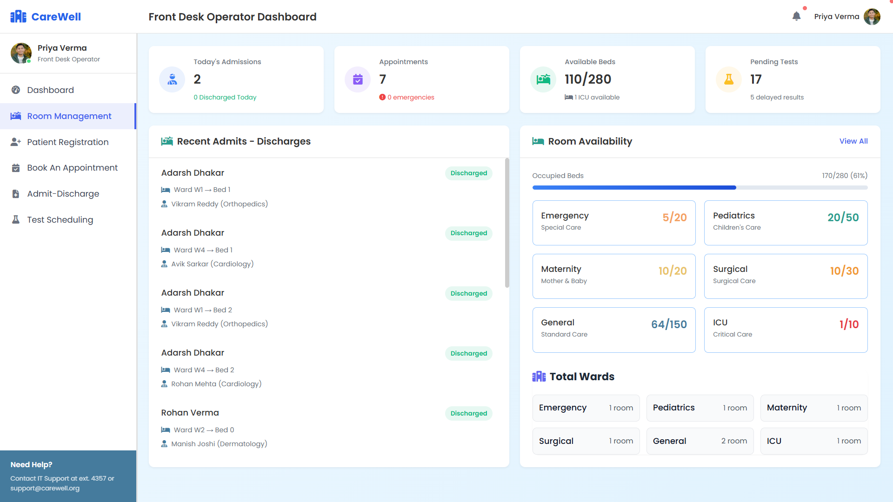

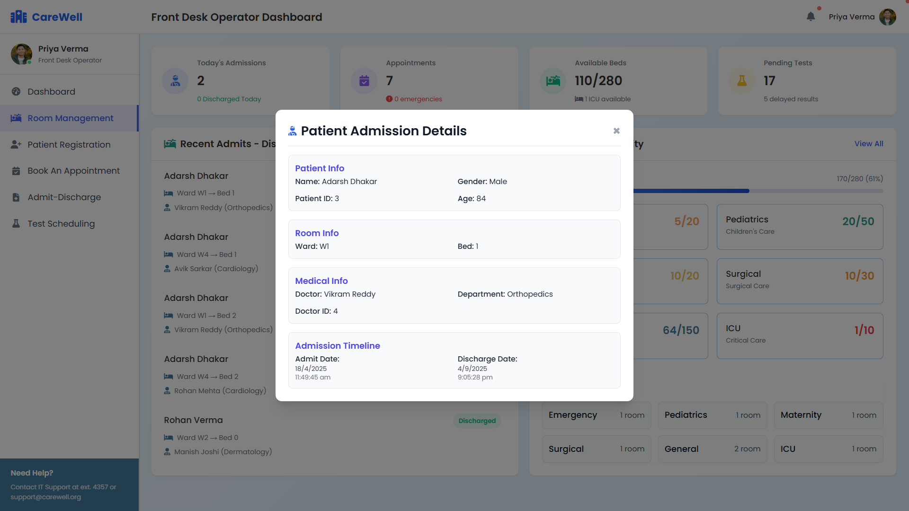

Registration

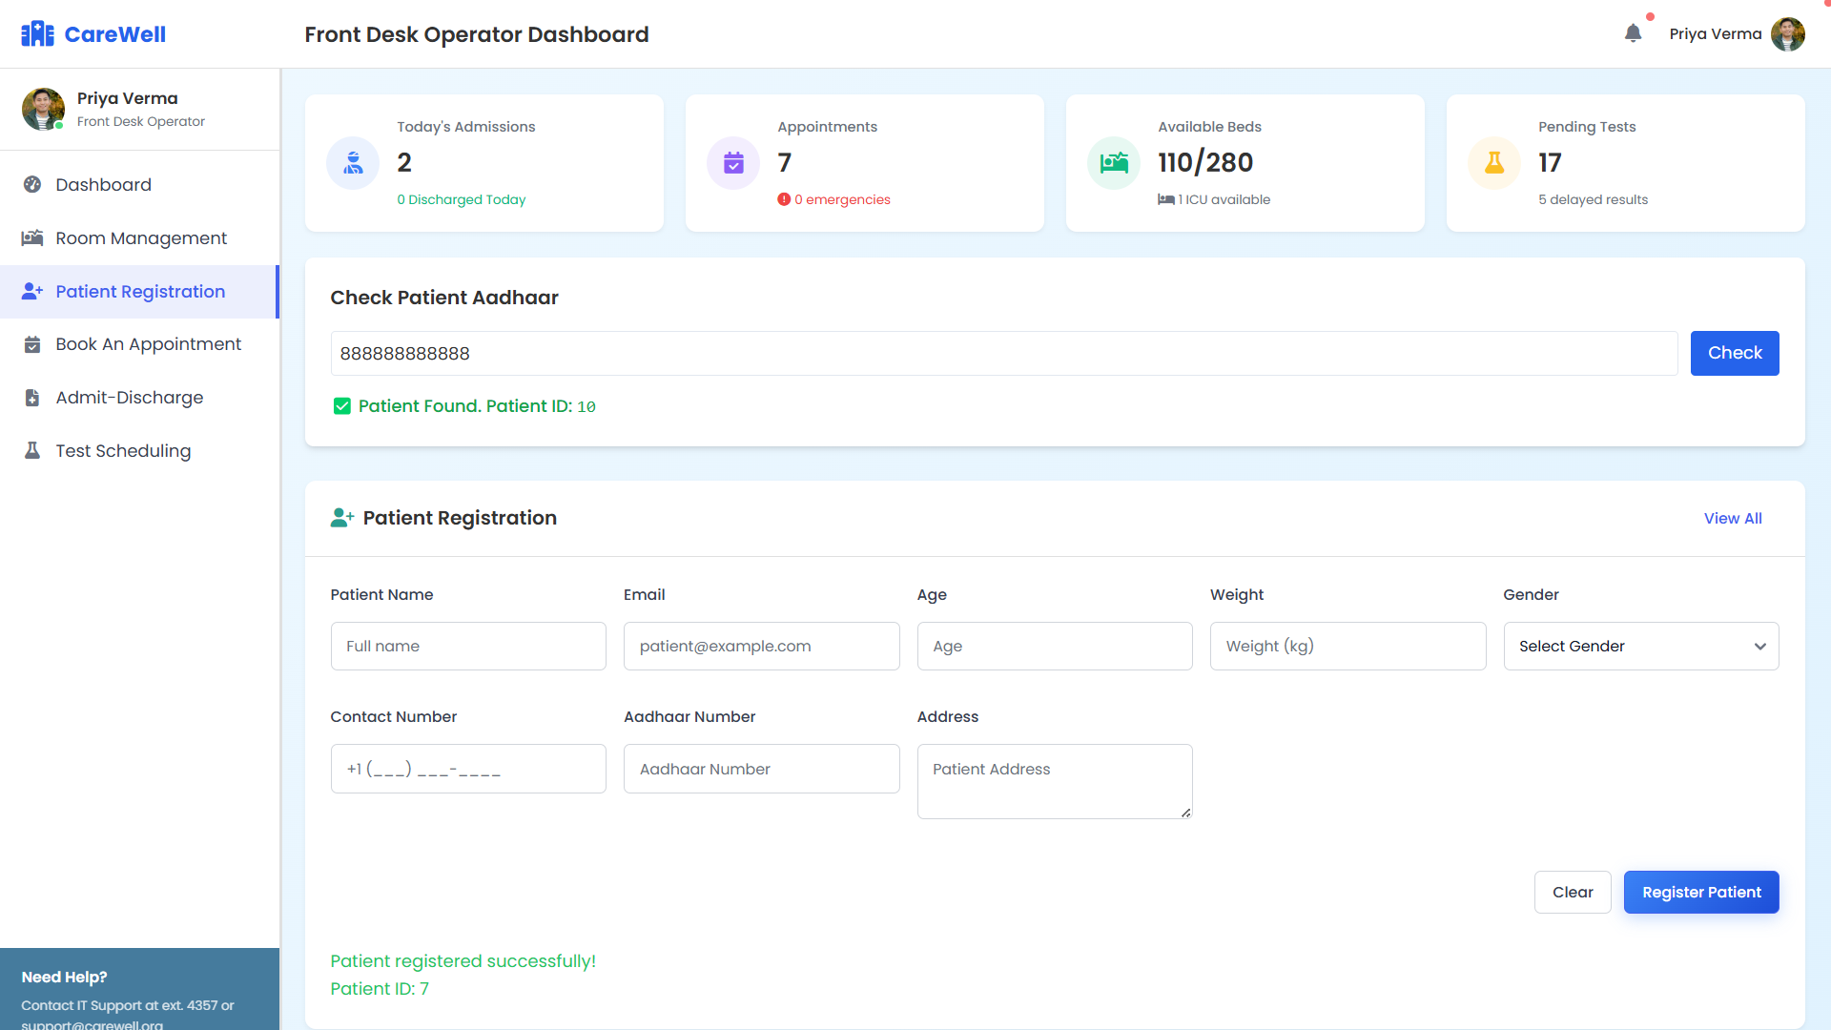

Book Appointment

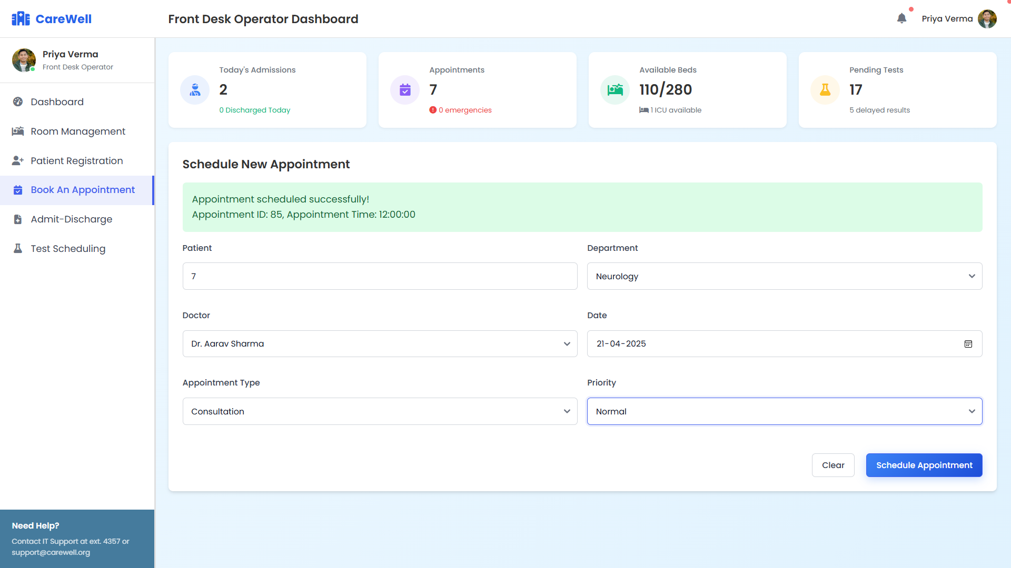

Admit/Discharge

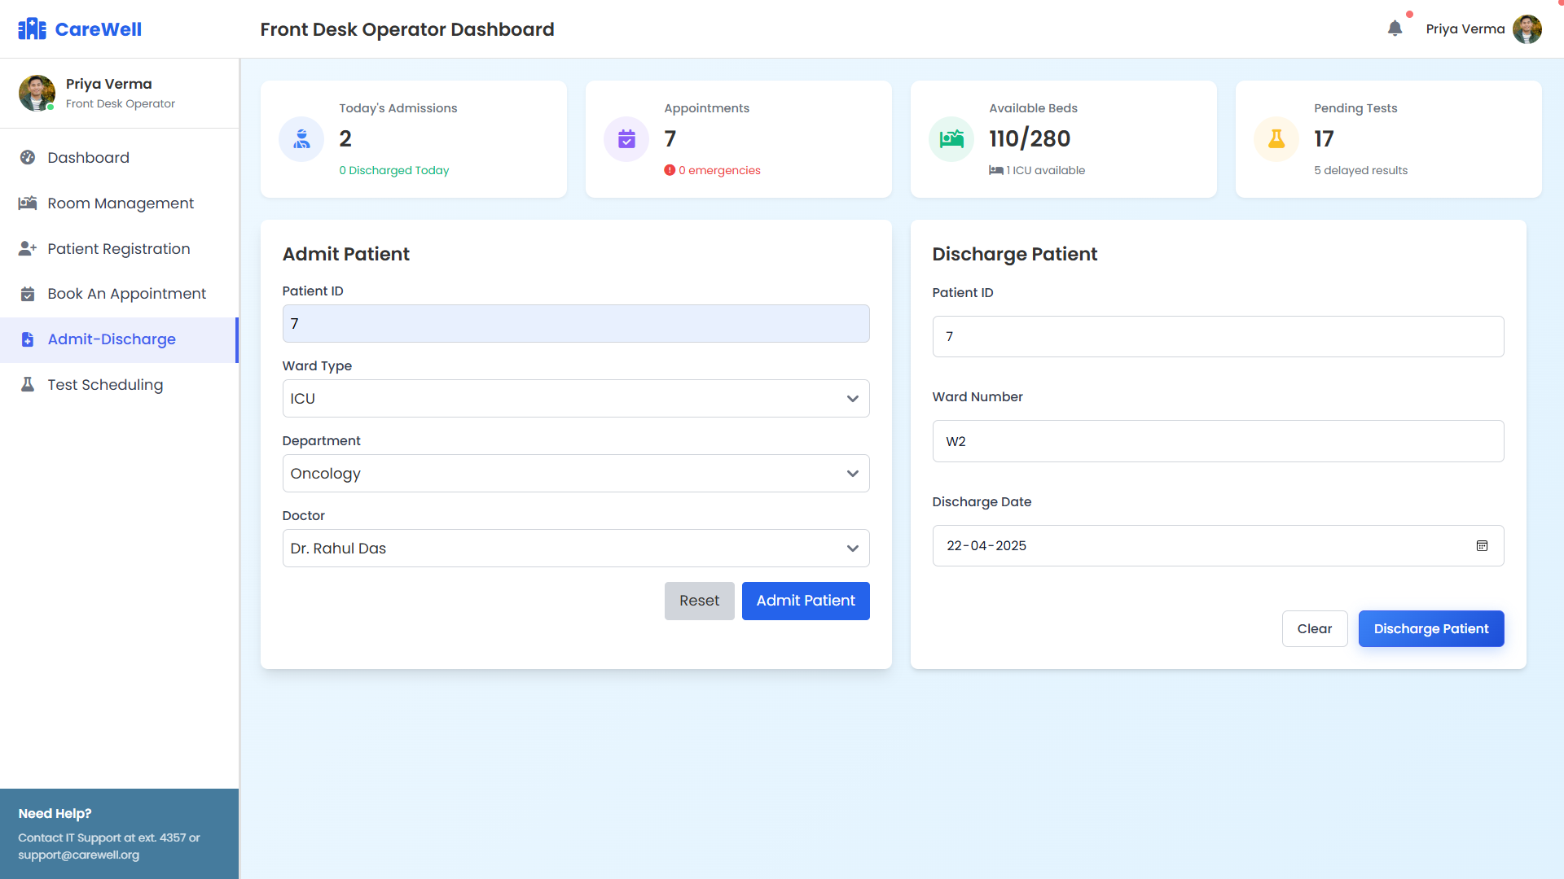

Test Scheduling

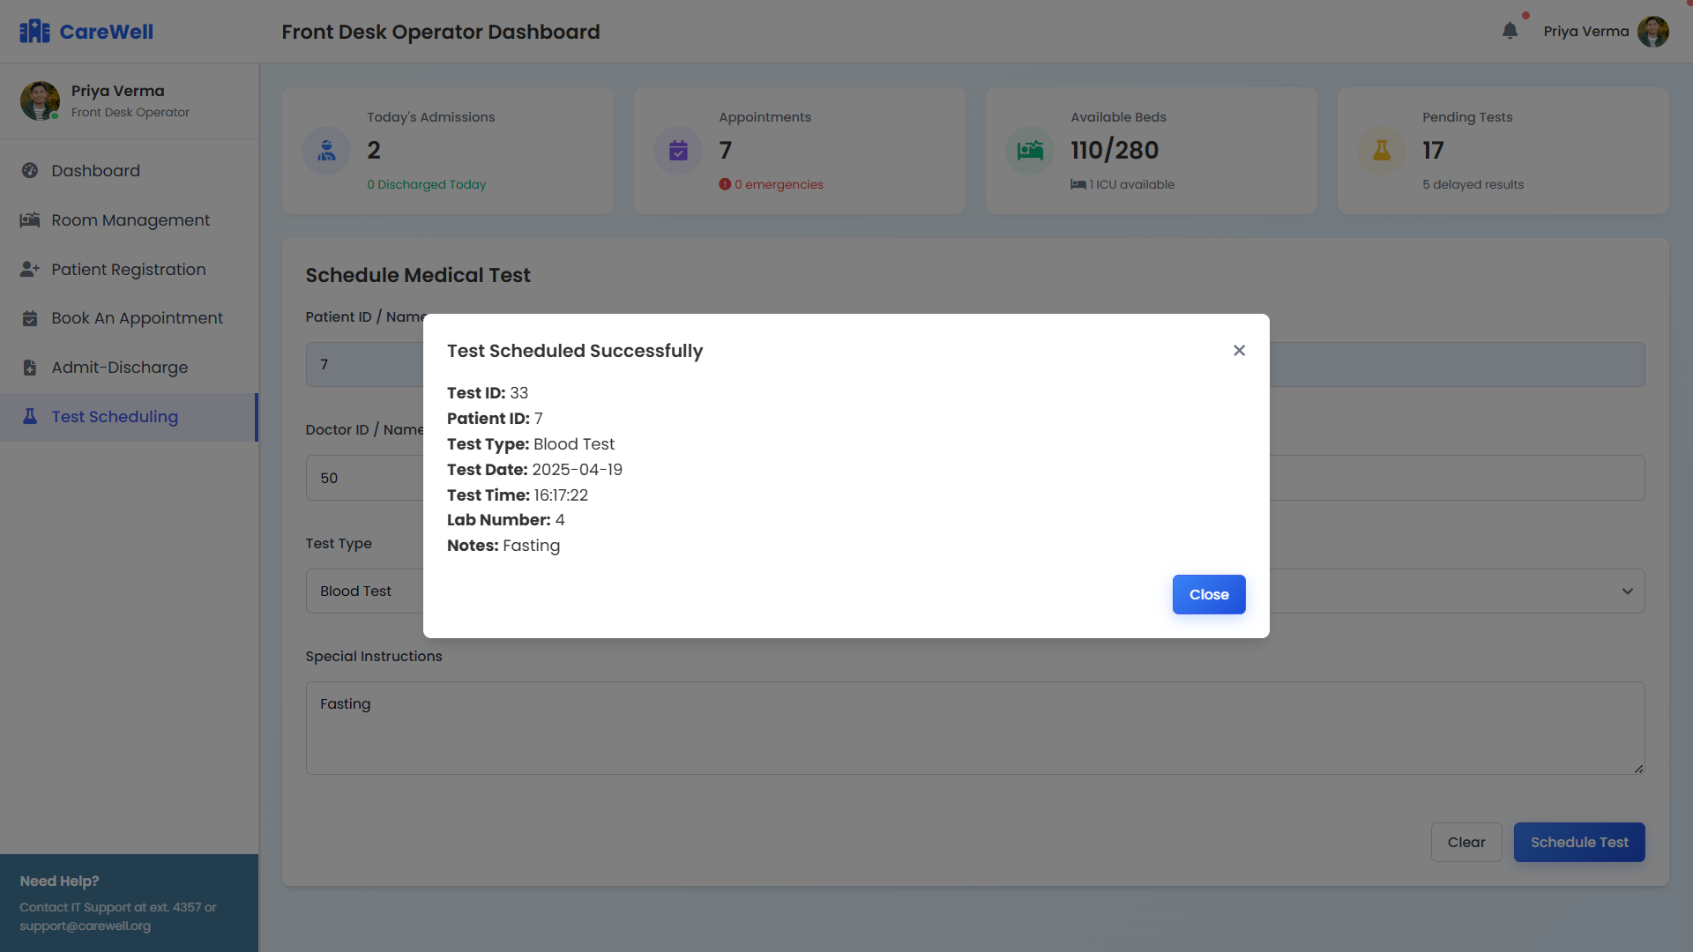

Doctor:

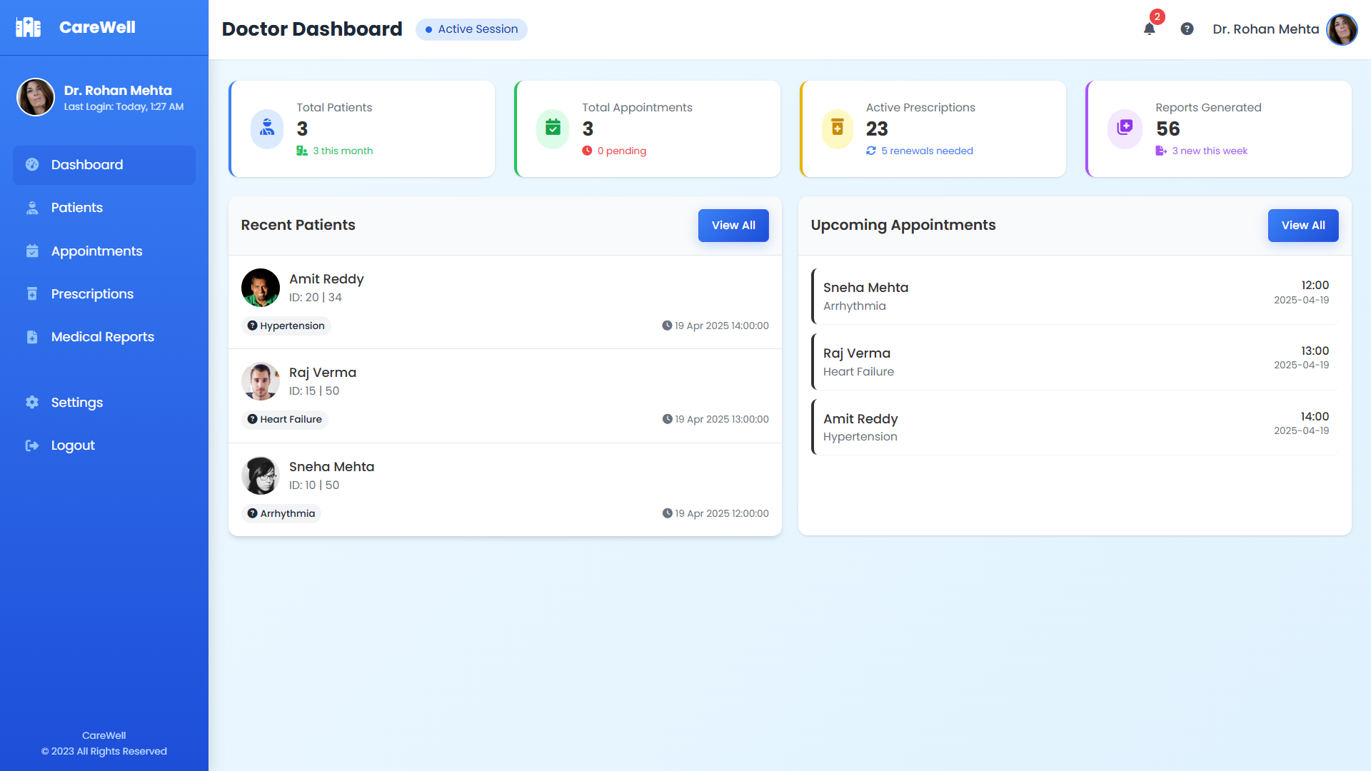

Query Patients

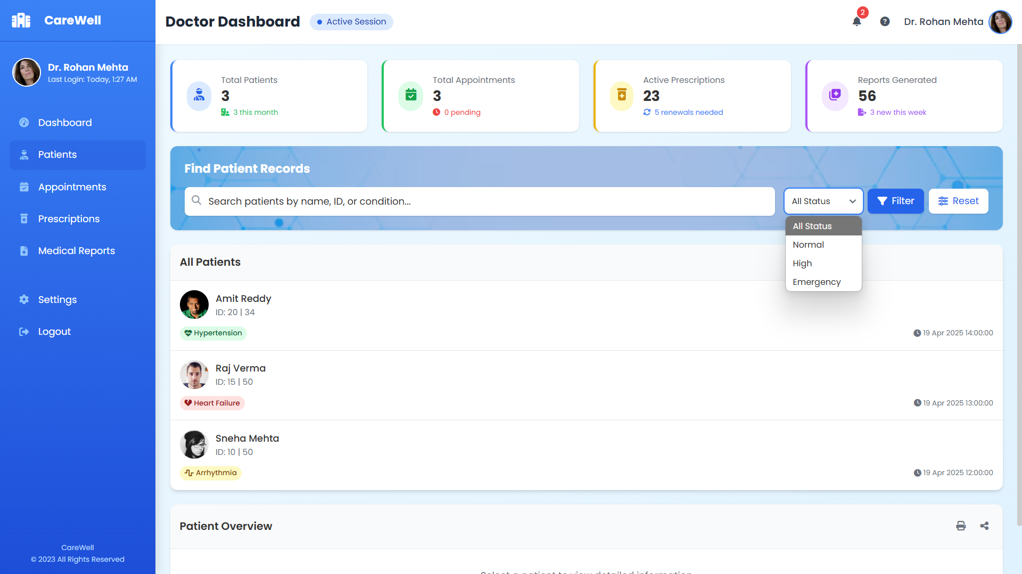

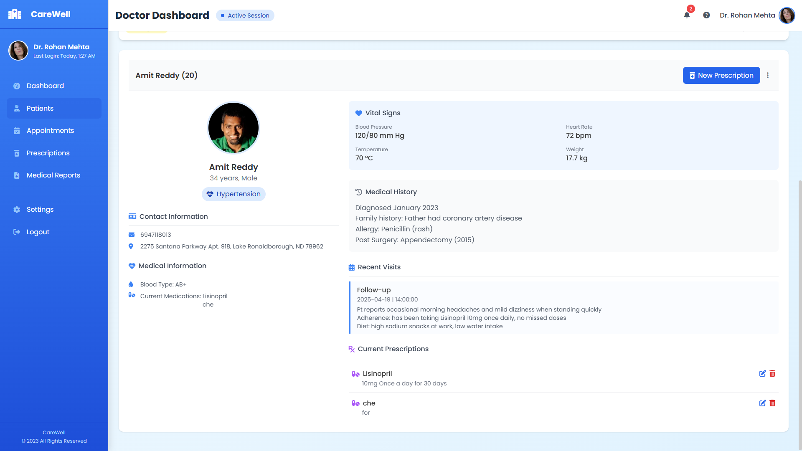

Query Appointments

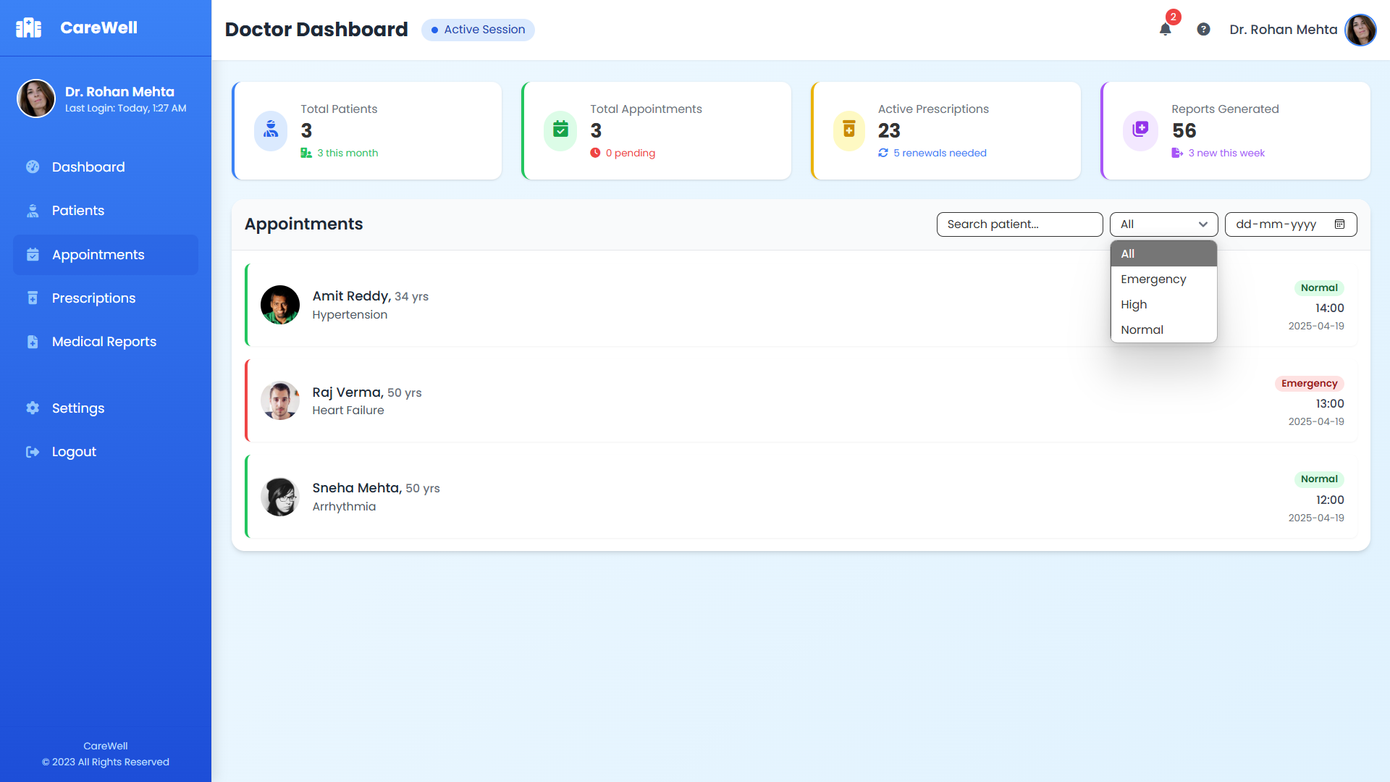

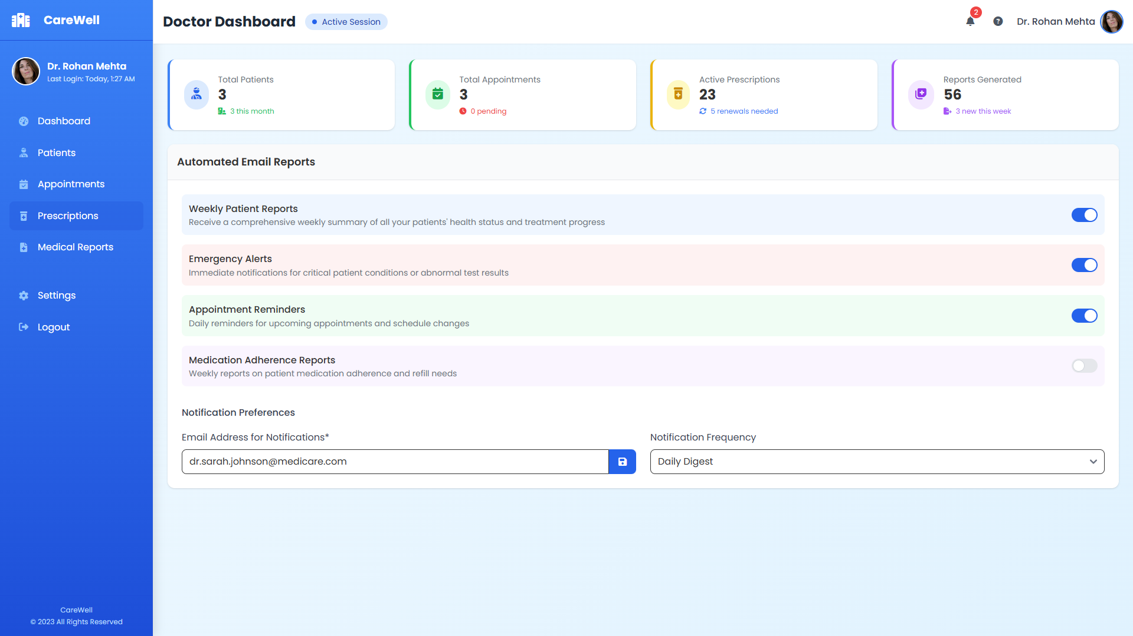

Data Entry Operator: Find Patient corresponding to a doctor

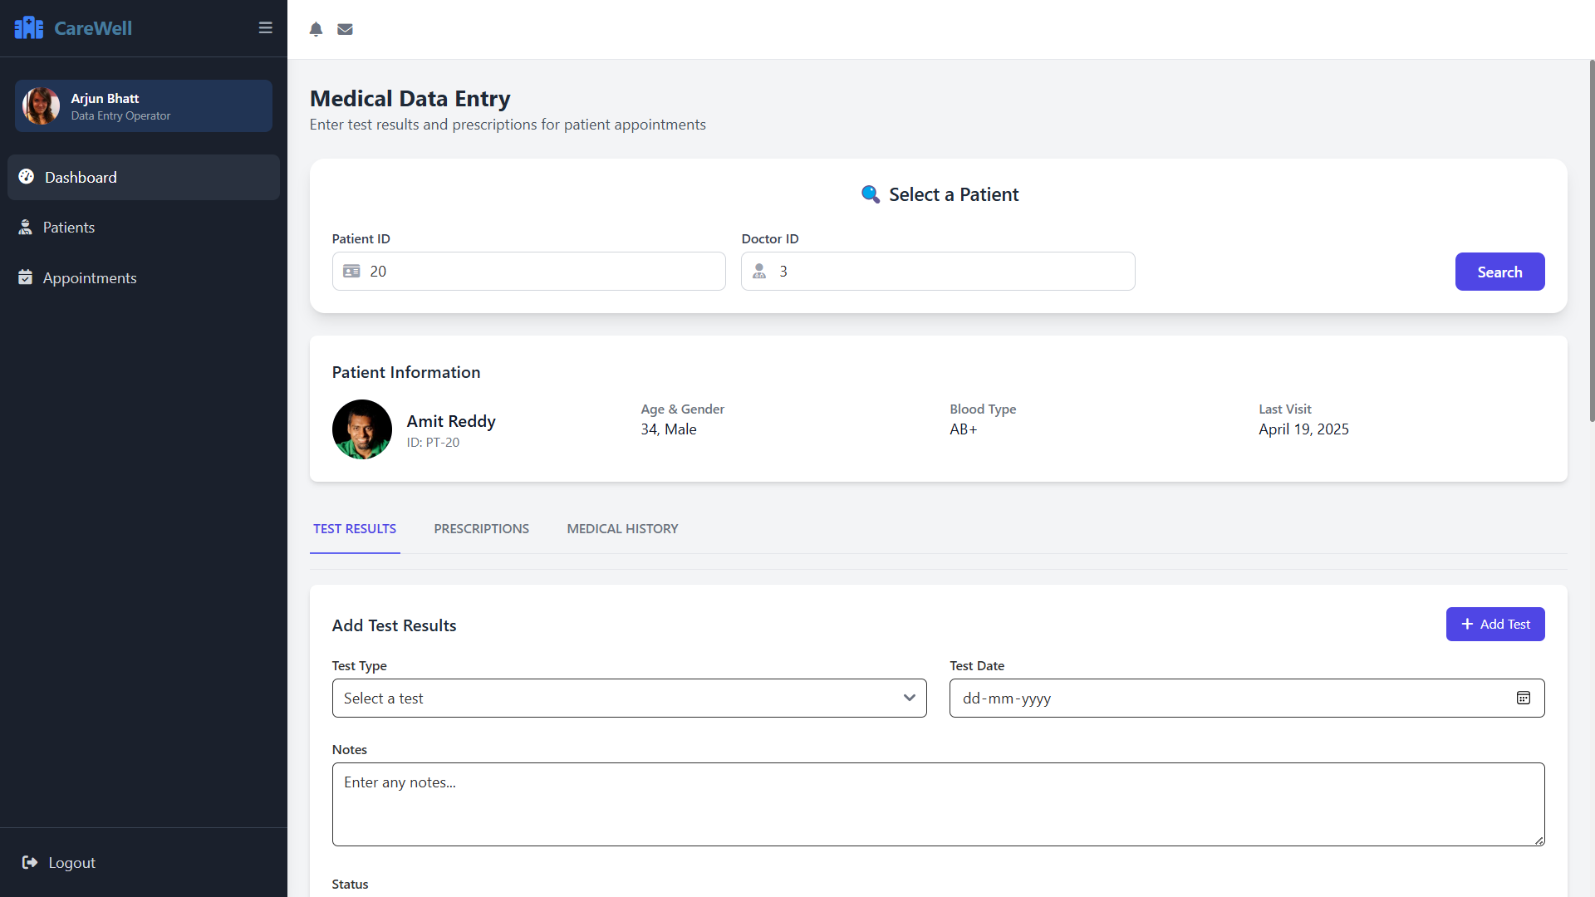

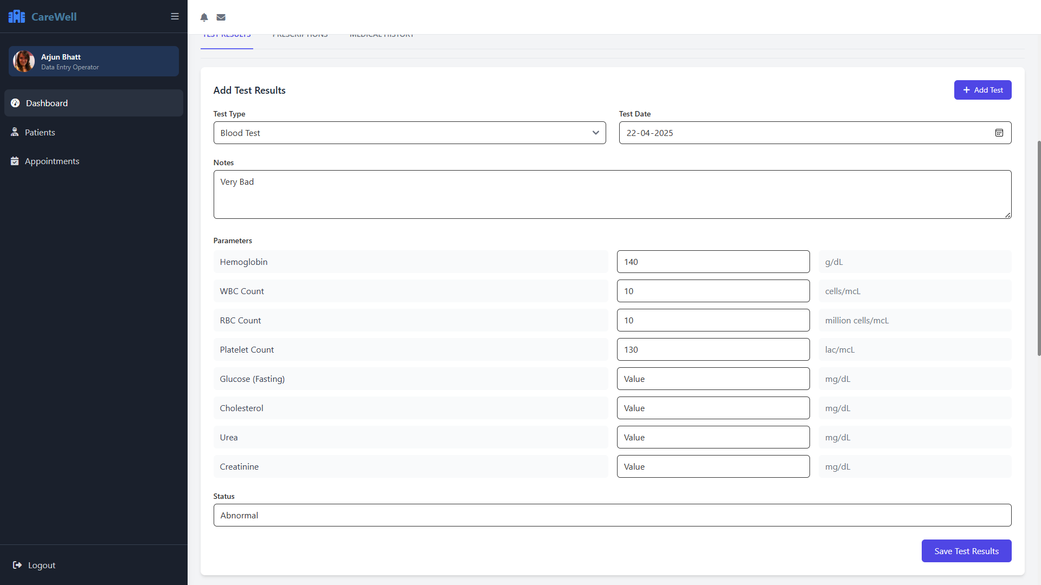

Previous Test Result

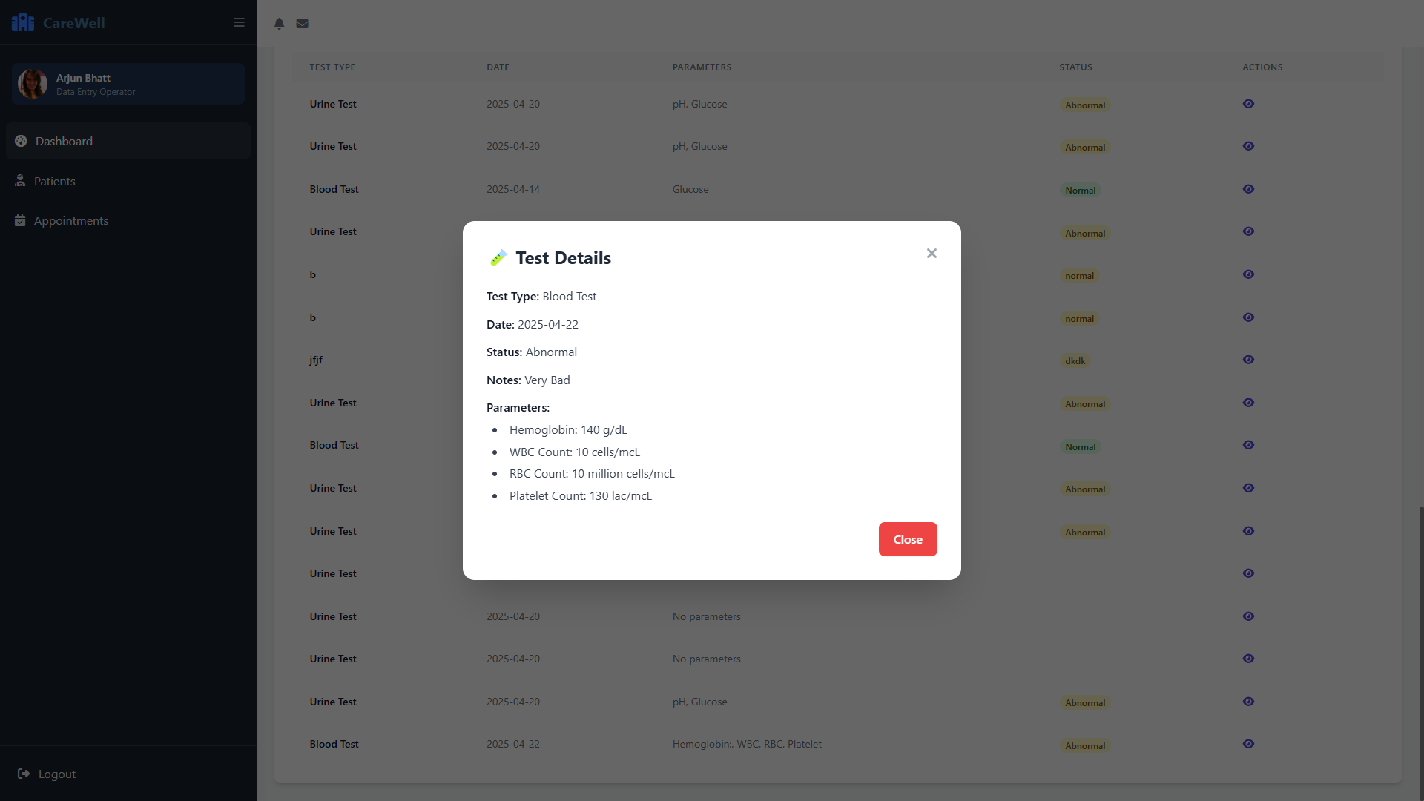

Add and View All Prescriptions

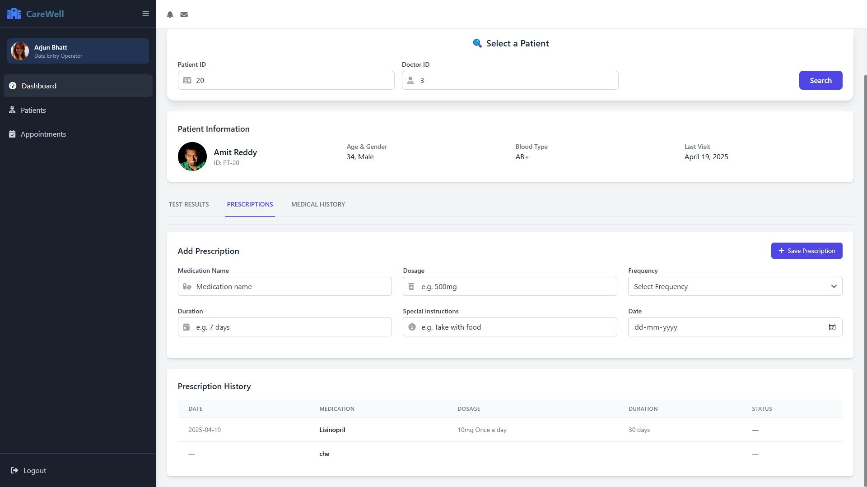

Medical History

